|  |  |
| --- | --- |
| PRECAUTIONS   1. If odbc not giving you the option Microsoft Access Driver(*.mdb, *.accdb), then you need run the access data base engine first 32bit or 64bit as per your operatin system machine.      1. It’s a case sensitive issue you must set the column heads in access table with Capital letters otherwise oracle will not call fields with small letters column heads.       Configure DB link to MS Access from Oracle  This document gives step by step instructions to set up a Database link in Oracle database to  access MS Access database (*mdb/*accdb).   1. Go to Control Panel-🡪Select Administrative tool-🡪Select Data Sources (ODBC)   Create an ODBC Data Source Name (DSN)  Select tab System DSN -🡪 then go to Add button on Right side -🡪  Select Microsoft Access Driver(*.mdb, *.accdb)  You can see below image for more help.    Now click on Finish this will open a new form to set data source name.  You can see below image for more help.    Set Data Dource name, then locate your access file through Select button ---Click on select button  You can see below image for more help.    1st select your drive where your access file is placed, this will prompt all .accdb files in left side list,  Select your specific file and click on ok button. Again click ok then connection is created from access  Now you need to make changes in oracle files. Which are given below   1. Start Oracle Files Changes   You have to make changes in 3 notepad files  1—listener.ora  2—tnsname.ora  3—initdg4odbc.ora  First start make change in 1st and 2nd file and these files location is given below:  For Oracle Enterprise Edition:  Go to E drive-🡪app folder--->Select your system name folder -🡪product🡪11.2.0-🡪dbhome_1🡪Network  -🡪admin  OR  E:\app\Saim-PC\product\11.2.0\dbhome_1\NETWORK\ADMIN  For Oracle Express Edition:  Follw the given path for listener and tnsnames files  C:\oraclexe\app\oracle\product\11.2.0\server\network\ADMIN   1. Update listener.ora taking following entry as example:   Note# the yellow portion is default no changes make in the yellow portion only add the green  portion just below the yellow portion.  SID_LIST_LISTENER =  (SID_LIST =  (SID_DESC =  (SID_NAME = CLRExtProc)  (ORACLE_HOME = E:\app\Saim-PC\product\11.2.0\dbhome_1)  (PROGRAM = extproc)  (ENVS = "EXTPROC_DLLS=ONLY:E:\app\Saim-PC\product\11.2.0\dbhome_1\bin\oraclr11.dll")  )    (SID_DESC =  (SID_NAME = softchan)  (ORACLE_HOME = D:\app\Administrator\product\11.2.0\dbhome_1)  (PROGRAM = dg4odbc)  (ENVS = "EXTPROC_DLLS=ONLY:D:\app\Administrator\product\11.2.0\dbhome_1\bin\oraclr11.dll")  ) *This bracket belongs to the yellow portion SID_LIST closing bracket*  Copy (SID_DESC-----------------TO----------(ENVS=--------)) from the yellow part and paste below  then make 2 changes.  Changes in green portion:   1. Set SID_NAME = Data source name which you set in point 1. 2. PROGRAM = dg4odbc   You can see below image for more help.     1. Update tnsnames.ora taking following entry as example:   Createa new service for access data source name.copy paste the yellow text and make change in green as per your system settings.  lineup =  (DESCRIPTION =  (ADDRESS = (PROTOCOL = TCP)(HOST = Saim-PC )(PORT = 1521))  (CONNECT_DATA =  (SERVER = DEDICATED)  (SERVICE_NAME = lineup)    )  (HS = OK)  )  Changes in green portion:   1. In 1st green lineup you can set any name which is your service name for calling the access db. 2. Set localhost or your pc name in HOST section. 3. Set service_name= Data source name which you set in point 1.   You can see below image for more help.    Now start make change in 3—initdg4odbc.ora file. Follow the below path  For Oracle Enterprise Edition:  Go to E drive-🡪app folder--->Select your system name folder -🡪product🡪11.2.0-🡪dbhome_1🡪hs🡪admin  OR  E:\app\Saim-PC\product\11.2.0\dbhome_1\hs\ADMIN  For Oracle Express Edition:  Follw the given path for initdg4odbc files  C:\oraclexe\app\oracle\product\11.2.0\server\hs\ADMIN   1. Copy paste the yellow portion with only change in green part is that change lineup with your service name that you set up in step 2 listener file.   HS_FDS_CONNECT_INFO = lineup  HS_FDS_SHAREABLE_NAME = C:\Windows\System32  HS_FDS_TRACE_LEVEL = debug  HS_AUTOREGISTER=true  You can see below image for more help.    And rename this file to initlineup.ora and save ------------init(tnsname)  Now finally go to services  Write services in run and click on services.   1. Restart Listener Services   For Oracle Enterprise Edition:  Restart the highlighted service.  You can see below image for more help.    For Oracle Enterprise Edition:  Restart the highlighted service.  You can see below image for more help.     1. Here your access connection with oracle is created, to check your connection do following steps.   Go to Command line through administrator and ping your service to check the connection b/w oracle and access db.  Write this command:  Tnsping (*your service name)*  Example:  Tnsping lineup  If you get this in reply:    It means you have created a successful connection b/w oracle and ms access.   1. Create a DB link in the local DB that you have :   Connect to sql with your schema name and password and create a db link using this command  Create database link *<any name>* using *‘your tnsname name’* ;  CREATE DATABASE LINK softchan_db USING 'softchan';  For example:  CREATE DATABASE LINK lineup_db USING 'lineup';  If user has set password security on access file then you need to make connection with this command  Create database link lineuppass connect to "softchan" identified by "sc" USING 'lineup';  Nadia is the user name of login name of computer.  saim is the password of access file  lineup is tns name   1. Now you can call your access tables in oracle using this command: | [Contact Me](http://www.dbheart.com/about.html) |

Connect to sql -🡪 then type this command

Select * from employee@lineup_db;

In above command employee is my access table and lineup_db my database link. And by using both of them I am calling access table on oracle plateform.

You can see below image for more help.

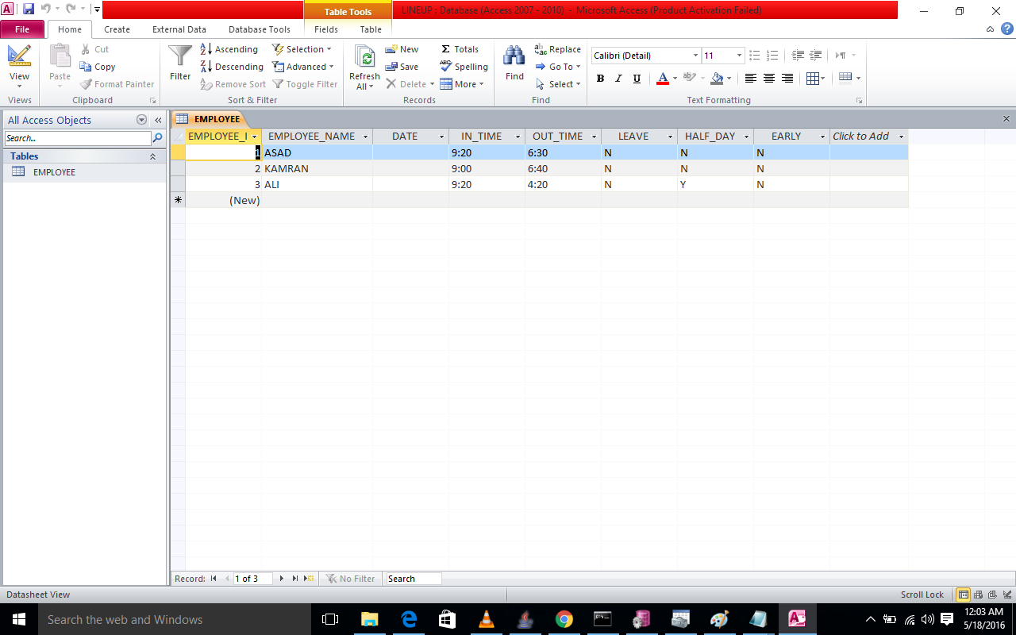

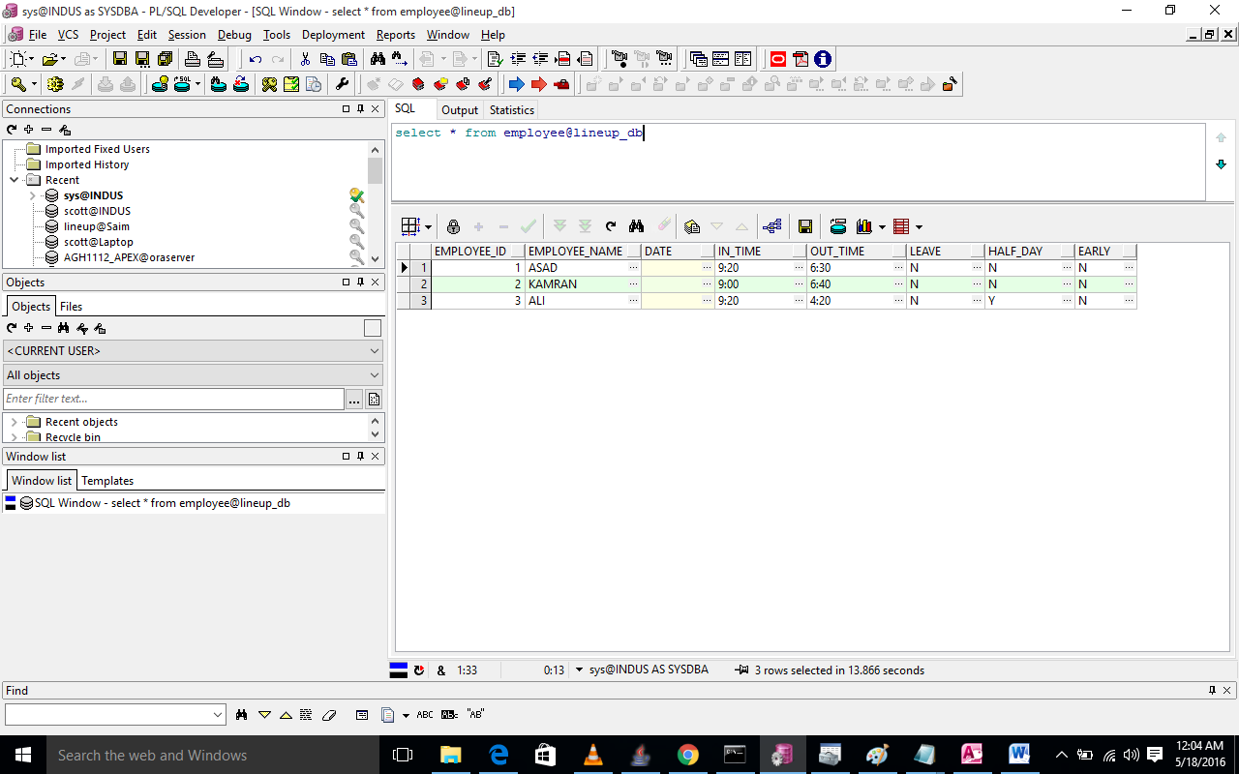

Hope this document will help you.